Database System Engineering and Distributed Backend Development
BANK DATABASE — SQL VIEWS

Name: Teja Hasini Reddy
Roll No: 2520030048
Section: 7
Email: tejahasinireddy@klh.edu.in

QUERY 1 — Create Database
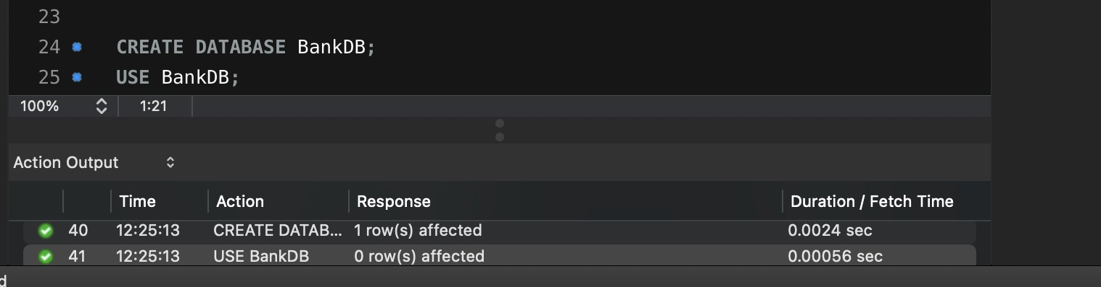
CREATE DATABASE BankDB; USE BankDB;

QUERY 2 — Create Customer Table
CREATE TABLE Customer ( Customer_ID INT PRIMARY KEY,
Customer_Name VARCHAR(100) NOT NULL, Phone VARCHAR(15),
Email VARCHAR(100), City VARCHAR(50)
);

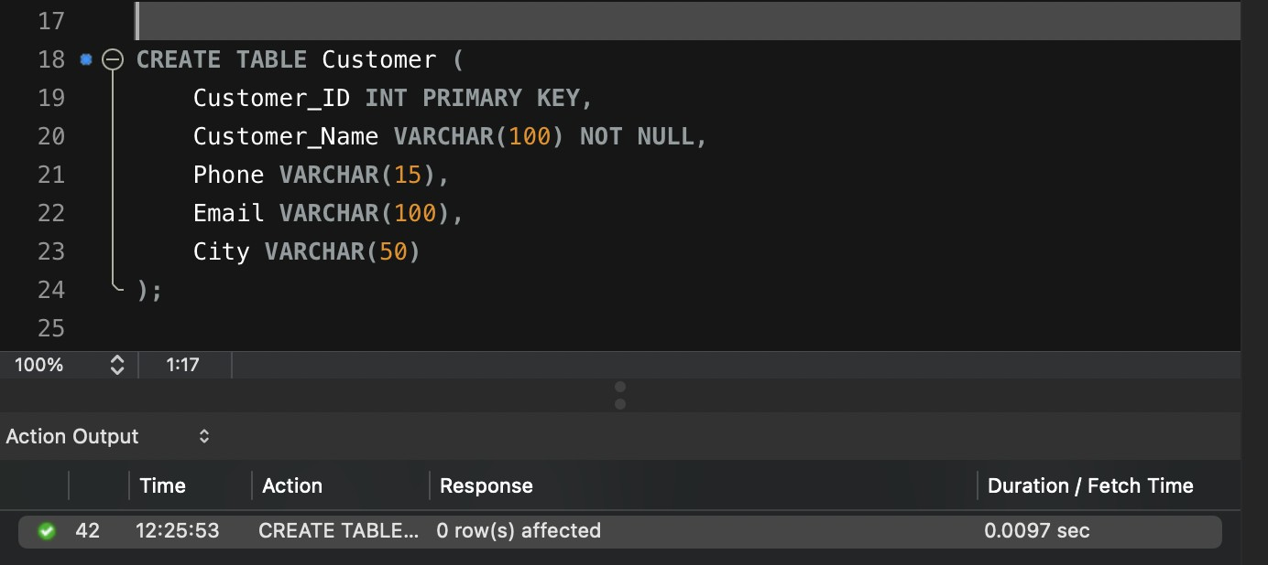
QUERY 3 — Create Account Table
CREATE TABLE Account ( Account_No INT PRIMARY KEY, Customer_ID INT, Account_Type VARCHAR(20), Balance DECIMAL(12,2), Branch VARCHAR(50),
FOREIGN KEY (Customer_ID) REFERENCES Customer(Customer_ID)
);
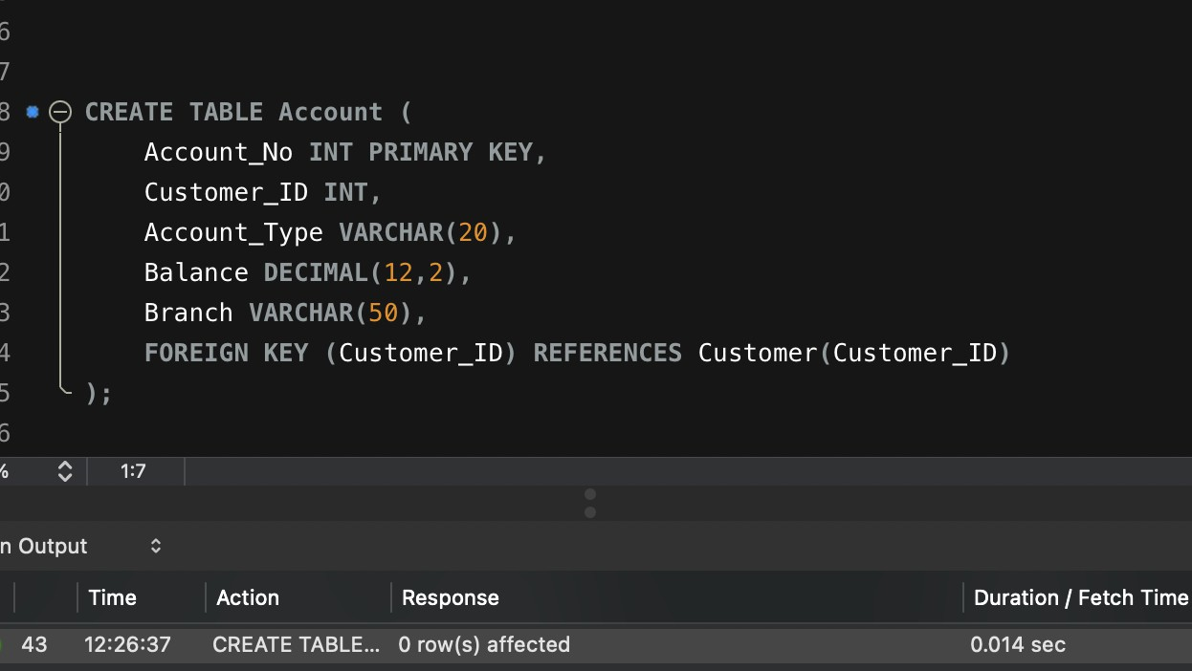

QUERY 4 — Create Bank_Transaction Table
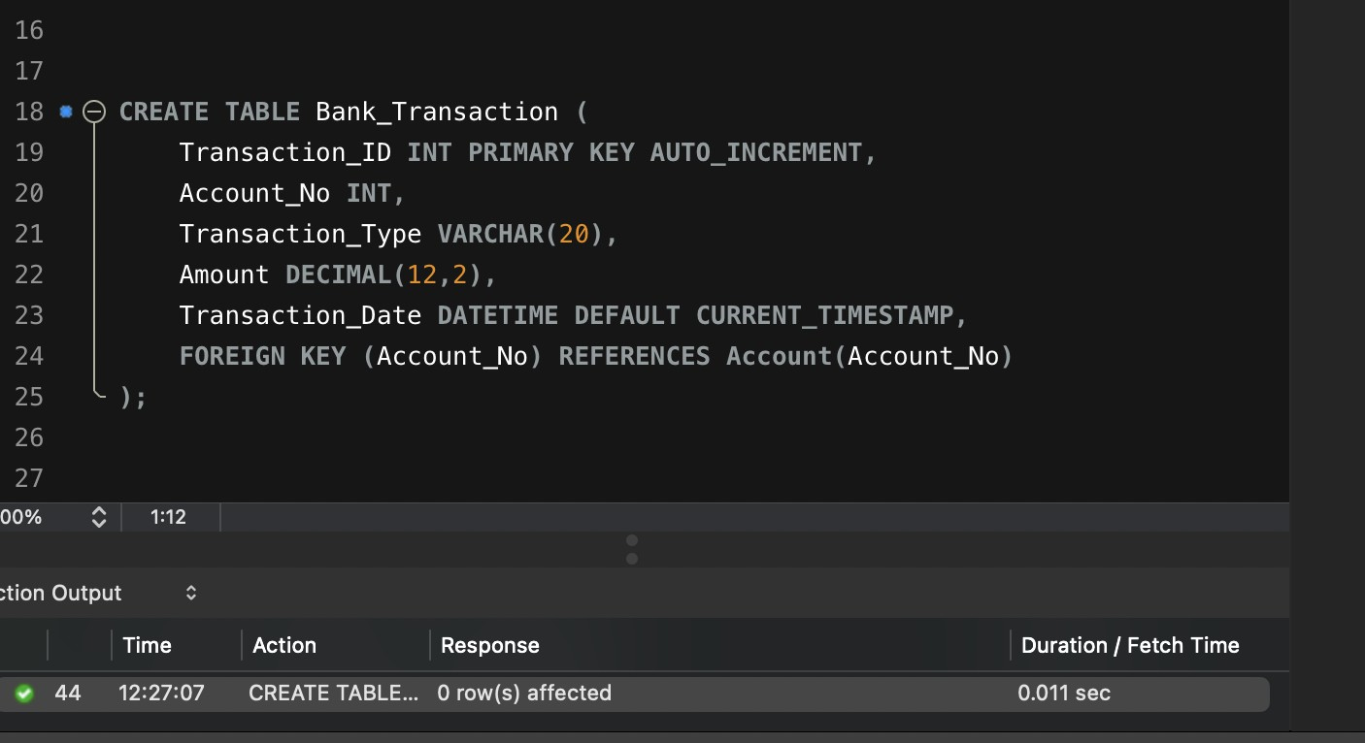
CREATE TABLE Bank_Transaction (
Transaction_ID INT PRIMARY KEY AUTO_INCREMENT,
Account_No INT, Transaction_Type VARCHAR(20), Amount DECIMAL(12,2),
Transaction_Date DATETIME DEFAULT CURRENT_TIMESTAMP, FOREIGN KEY (Account_No) REFERENCES Account(Account_No)
);

QUERY 5 — Create Loan Table
CREATE TABLE Loan (
Loan_ID INT PRIMARY KEY,
Customer_ID INT, Loan_Type VARCHAR(30), Loan_Amount DECIMAL(12,2),
Interest_Rate DECIMAL(5,2),
FOREIGN KEY (Customer_ID) REFERENCES Customer(Customer_ID)
);
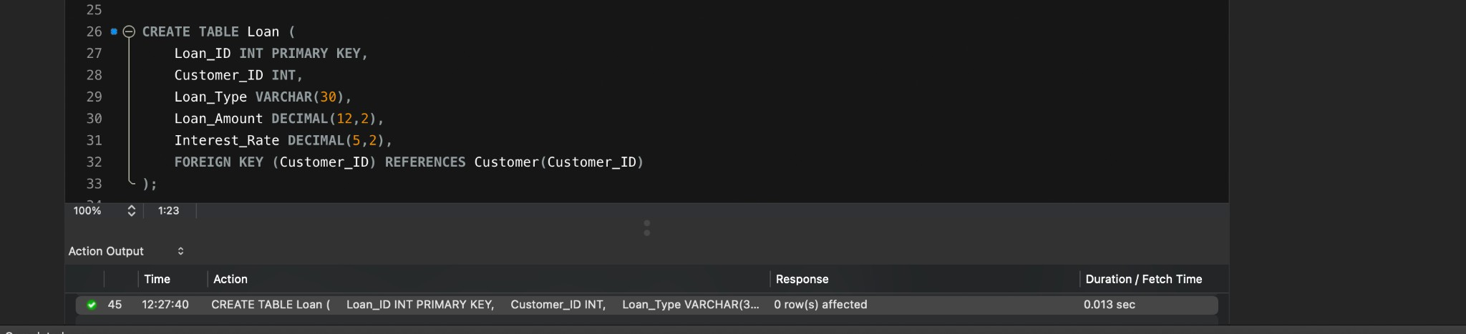

QUERY 6 — Insert Customer Records + Display
SELECT * FROM Customer;
INSERT INTO Customer (Customer_ID, Customer_Name, Phone, Email, City) VALUES
(101, 'Teja Hasini Reddy', '9876543210', 'tejahasinireddy@klh.edu.in', 'Hyderabad'),
SELECT * FROM Account;
INSERT INTO Account (Account_No, Customer_ID, Account_Type, Balance, Branch)
VALUES

(102, | 'Priya Sharma', '9876543211', 'priya.sharma@gmail.com', 'Vijayawada'),
(103, | 'Arjun Reddy', '9876543212', 'arjun.reddy@gmail.com', 'Bangalore'),
(104, | 'Sneha Rao', '9876543213', 'sneha.rao@gmail.com', 'Chennai'),
(105, | 'Kiran Kumar', '9876543214', 'kiran.kumar@gmail.com', 'Hyderabad'),
(106, | 'Anil Verma', '9876543215', 'anil.verma@gmail.com', 'Delhi'),
(107, | 'Meena Iyer', '9876543216', 'meena.iyer@gmail.com', 'Mumbai'),
(108, | 'Rahul Nair', '9876543217', 'rahul.nair@gmail.com', 'Pune'),
(109, | 'Lakshmi Devi', '9876543218', 'lakshmi.devi@gmail.com', 'Hyderabad'),
(110, | 'Suresh Babu', '9876543219', 'suresh.babu@gmail.com', 'Vijayawada');

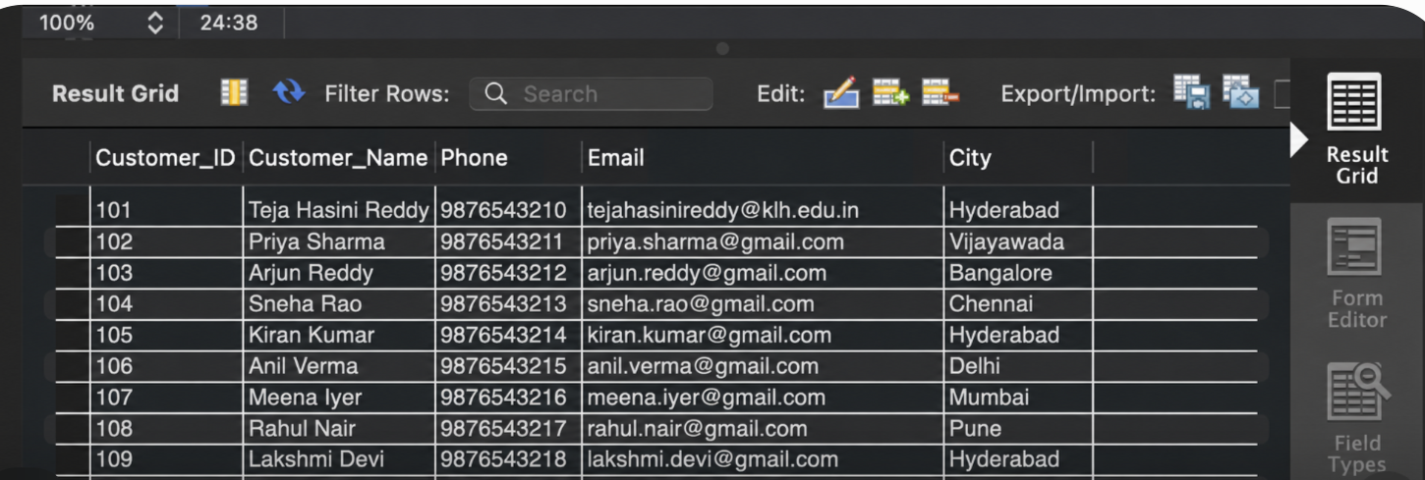
QUERY 7 — Insert Account Records + Display

(10001, | 101, | 'Savings', | 50000, 'Hyderabad'),
(10002, | 102, | 'Savings', | 75000, 'Vijayawada'),
(10003, | 103, | 'Current', | 120000, 'Bangalore'),
(10004, | 104, | 'Savings', | 45000, | 'Chennai'),
(10005, | 105, | 'Current', | 90000, | 'Hyderabad'),
(10006, | 106, | 'Savings', | 65000, | 'Delhi'),
(10007, | 107, | 'Current', | 150000, 'Mumbai'),
(10008, | 108, | 'Savings', | 35000, 'Pune'),
(10009, | 109, | 'Savings', | 85000, 'Hyderabad'),
(10010, | 110, | 'Current', | 110000, 'Vijayawada');

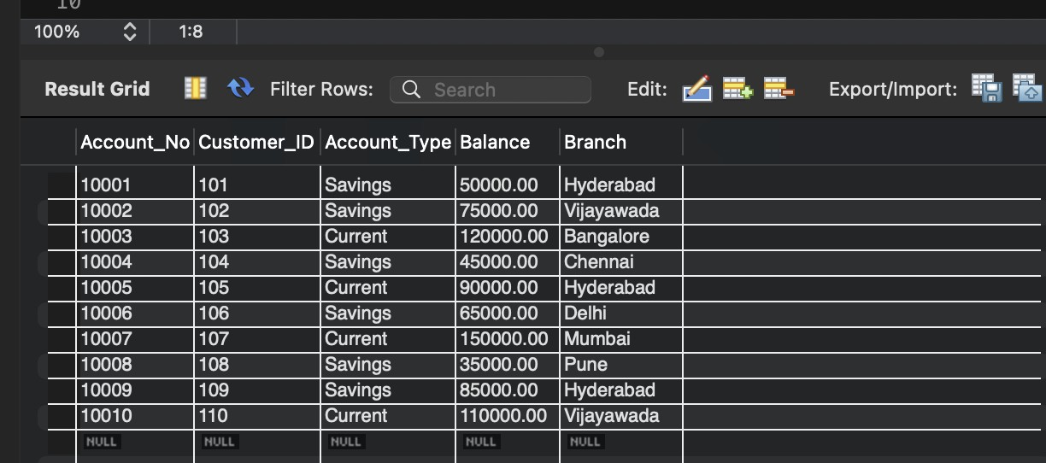
QUERY 8 — Insert Bank_Transaction Records + Display
SELECT * FROM Bank_Transaction;
INSERT INTO Bank_Transaction (Account_No, Transaction_Type, Amount) VALUES

(10001, | 'DEPOSIT', 10000),
(10001, | 'WITHDRAW', 5000),
(10002, | 'DEPOSIT', 15000),
(10003, | 'WITHDRAW', 20000),
(10004, | 'DEPOSIT', 5000),
(10005, | 'WITHDRAW', 10000),
(10006, | 'DEPOSIT', 12000),
(10007, | 'DEPOSIT', 25000),
(10008, | 'WITHDRAW', 5000),
(10009, | 'DEPOSIT', 20000),
(10010, | 'WITHDRAW', 15000);

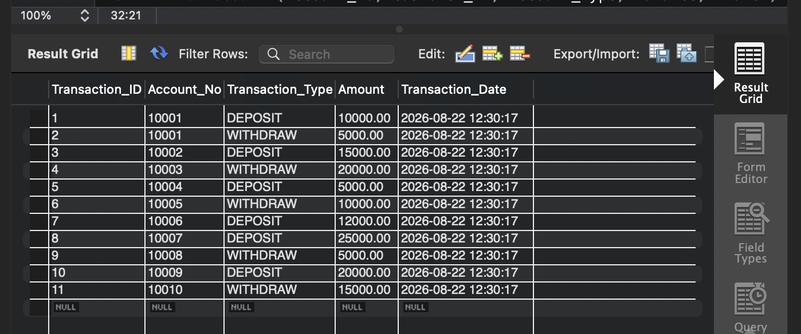

QUERY 9 — Insert Loan Records + Display
SELECT * FROM Loan;
INSERT INTO Loan (Loan_ID, Customer_ID, Loan_Type, Loan_Amount, Interest_Rate)
VALUES

(501, | 101, | 'Home Loan', 5000000, 7.5),
(502, | 102, | 'Education Loan', 1000000, 6.5),
(503, | 103, | 'Car Loan', 800000, 8.2),
(504, | 104, | 'Personal Loan', 500000, 10.5),
(505, | 105, | 'Home Loan', 4000000, 7.2),
(506, | 106, | 'Car Loan', 900000, 8.5),
(507, | 107, | 'Business Loan', 3000000, 9.0),
(508, | 109, | 'Personal Loan', 600000, 10.0);

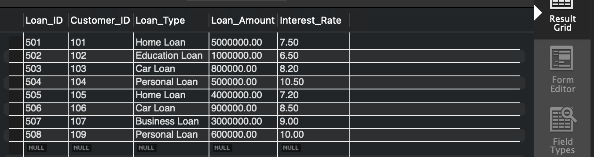

QUERY 10 — Simple View (View of an Entire Table)
CREATE VIEW Customer_View AS SELECT * FROM Customer;

SELECT * FROM Customer_View;
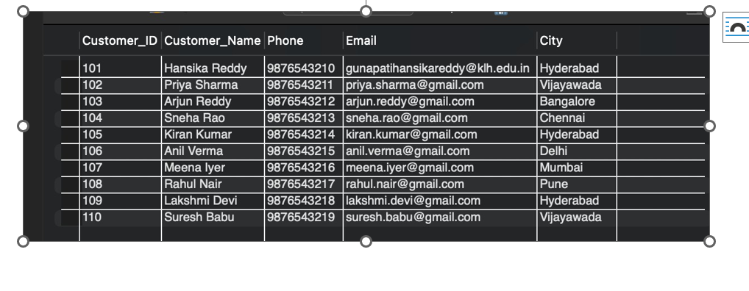

QUERY 11 — View Using WHERE (Filtered View)
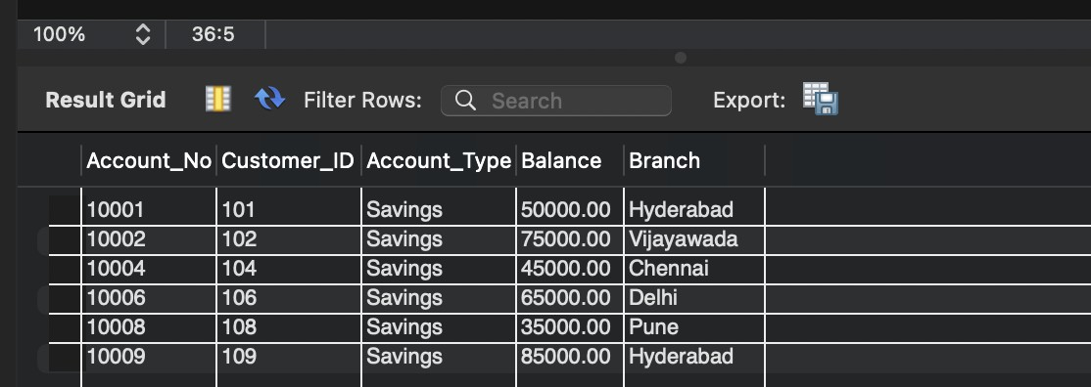
CREATE VIEW Savings_Account_View AS SELECT * FROM Account
WHERE Account_Type = 'Savings';

SELECT * FROM Savings_Account_View;

QUERY 12 — View Using JOIN (Combining Two Tables)
CREATE VIEW Customer_Account_View AS SELECT
C.Customer_ID, C.Customer_Name, C.City, A.Account_No, A.Account_Type, A.Balance, A.Branch
FROM Customer C
JOIN Account A ON C.Customer_ID = A.Customer_ID;

SELECT * FROM Customer_Account_View;
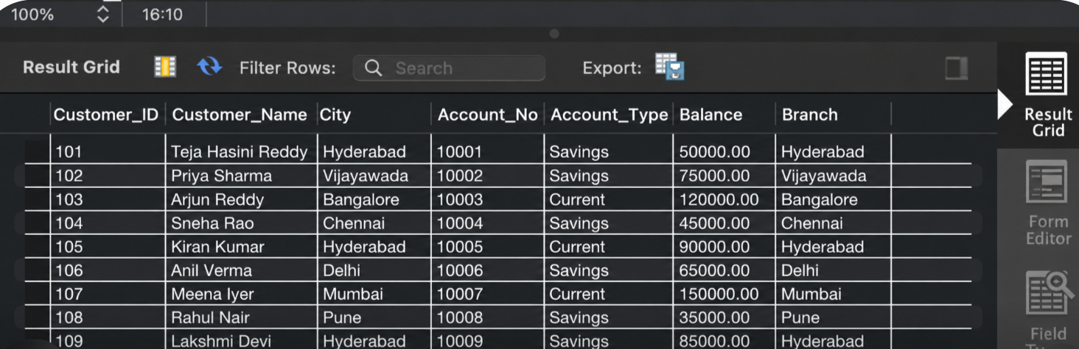
QUERY 13 — View Using GROUP BY + Aggregate Function
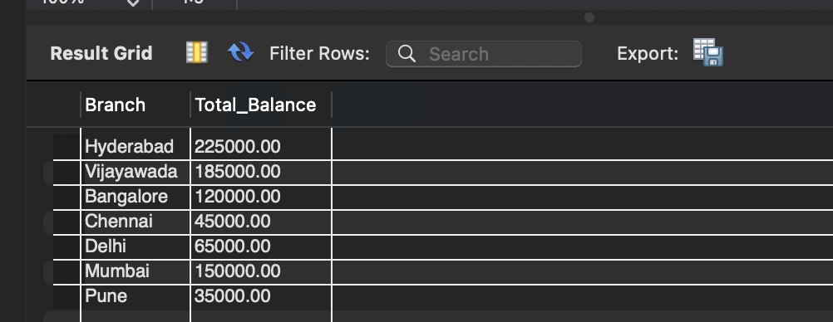
CREATE VIEW Branch_Total_Balance AS SELECT
Branch,
SUM(Balance) AS Total_Balance FROM Account
GROUP BY Branch;

SELECT * FROM Branch_Total_Balance;

QUERY 14 — View Using HAVING (Filter After Grouping)
CREATE VIEW Rich_Branches AS SELECT
Branch,
SUM(Balance) AS Total_Balance FROM Account
GROUP BY Branch
HAVING SUM(Balance) > 100000;

SELECT * FROM Rich_Branches;
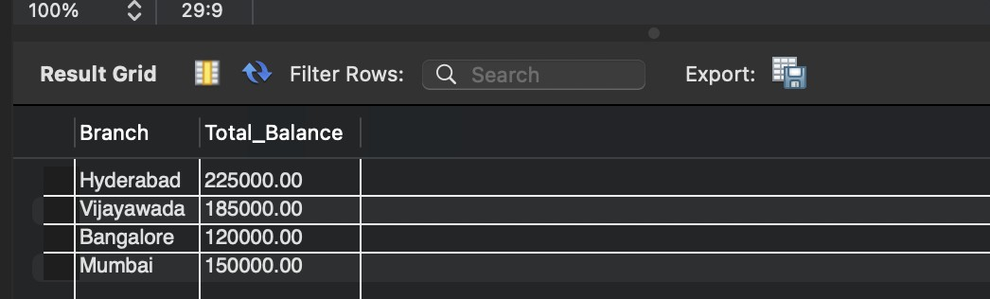

QUERY 15 — Update Through a View + Drop a View
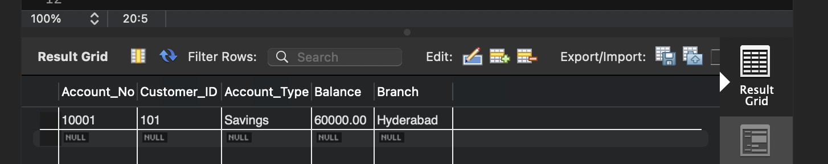
CREATE VIEW Account_View AS
SELECT Account_No, Customer_ID, Account_Type, Balance, Branch FROM Account;

UPDATE Account_View SET Balance = 60000
WHERE Account_No = 10001;
SELECT * FROM Account WHERE Account_No = 10001; DROP VIEW Account_View;

